Why were the LA Fires so Severe?

***Due date in Canvas*: All pages of this document must be printed out and turned in at beginning of class**

Background

In this project we will explore the role of precipitation and temperature variations in setting the stage for Los Angeles wildfires of January 2025, and then also look at a measure of drought known as the Palmer Drought Index that incorporates both. But why not just use precipitation data to assess drought and environmental dryness? That’s a good question, and generally, [precipitation deficits are the most important driver of drought](https://www.ncdc.noaa.gov/cag/national/time-series) – particularly during the cooler months when there is very little evaporation. But in the warmer months, evaporation and evapotranspiration are also major factors in determining availability of moisture for plants. And since summers are fairly dry along the Pacific Coast of the United States, temperature (and thus evaporation and evapotranspiration) is highly significant in driving moisture availability in the soil.

In thinking this through so that you will understand better the data you will be looking at, here are a few conceptual questions.

Question 1: Imagine two summers (June, July, August) that each received about 2 inches of rainfall, considered average for a particular region. One summer was cooler than average, the other was warmer than average.

1. Everything else being equal, which summer would be more likely to dry out plants, the cooler or warmer one?
2. Explain:

Question 2: Since late fall through early spring is the wet season on all of the Pacific Coast of California, the ability for soils and related ecosystems to store moisture is mostly determined by the rainfall during those months, especially November through March. These also happen to be the cooler months for the region.

1. The presence of perennial and annual plants in Southern California is connected directly to the climate of the region. Some of the plants, especially perennial small trees and bushes, are able to remain green in the summer. What does that suggest about the ability of the soils to hold moisture beyond the rainy season?
2. But even given what is written just above, perennial vegetation that makes it through the summer still needs moisture to stay alive and thrive into the early fall, and is adapted to an October or even November start of the rains. Discuss what you think might be most important for determining fire risk in the region by January, winter temperatures or winter rainfall:

Fires need fuel to burn, so the amount of vegetation that is available, together with how dry it is, influences its combustibility. Favorable weather for growing vegetation provides sufficient precipitation to accumulate soil moisture. Since this happens in Southern California during the usual rainy season, we will focus on the precipitation of the wetter months of November through March. Keep in mind that the temperature-based growing season for coastal Southern California is year round, but that annual plants, and some perennials too, do most of their growing during and just after the winter and early spring rains, when moisture is less likely to be limiting. (note that one cause of the severity of the fires is the multi-decadal accumulation of vegetation in some areas – though this is beyond the scope of our study)

Accordingly, we will utilize a simple model to examine how unusual the meteorological variables were going back just over a year before the big fires of early January 2025:

Nov 2023 – June – Oct. Oct. – Dec. 2024 temperatures, March 2024 temperatures 2024 rainfall & drought index data precipitation

accelerated evapotranspiration/H20 loss more desiccation or H20 plant growth? xxxxxxxxxxxxxxxxdessication?xxxxxxxxxxxxxxxxxxxxxxxxxxxrenewal?

Having significant vegetation as fuel and dry weather to make it combustible are both necessary conditions for the kind of explosive fires of January 2025. Nonetheless, the occurrence of strong winds contributed to the development of the most severe fires that happened in the region. But for the purpose of simplicity we will focus on the variables outlined in the above diagram.

Our data set is for Los Angeles County, where most of the severe fires developed: <https://www.ncei.noaa.gov/access/monitoring/climate-at-a-glance/county/time-series>

A fires map and also a map showing LA County are found below:

Map of LA Fires: 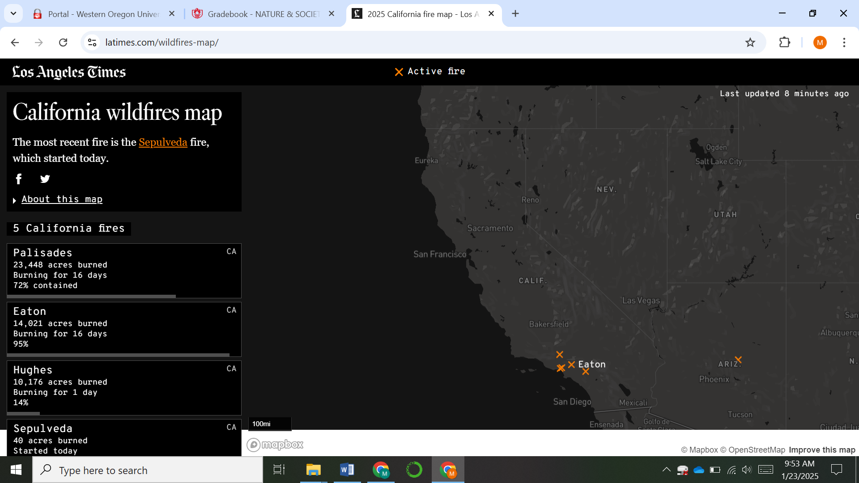

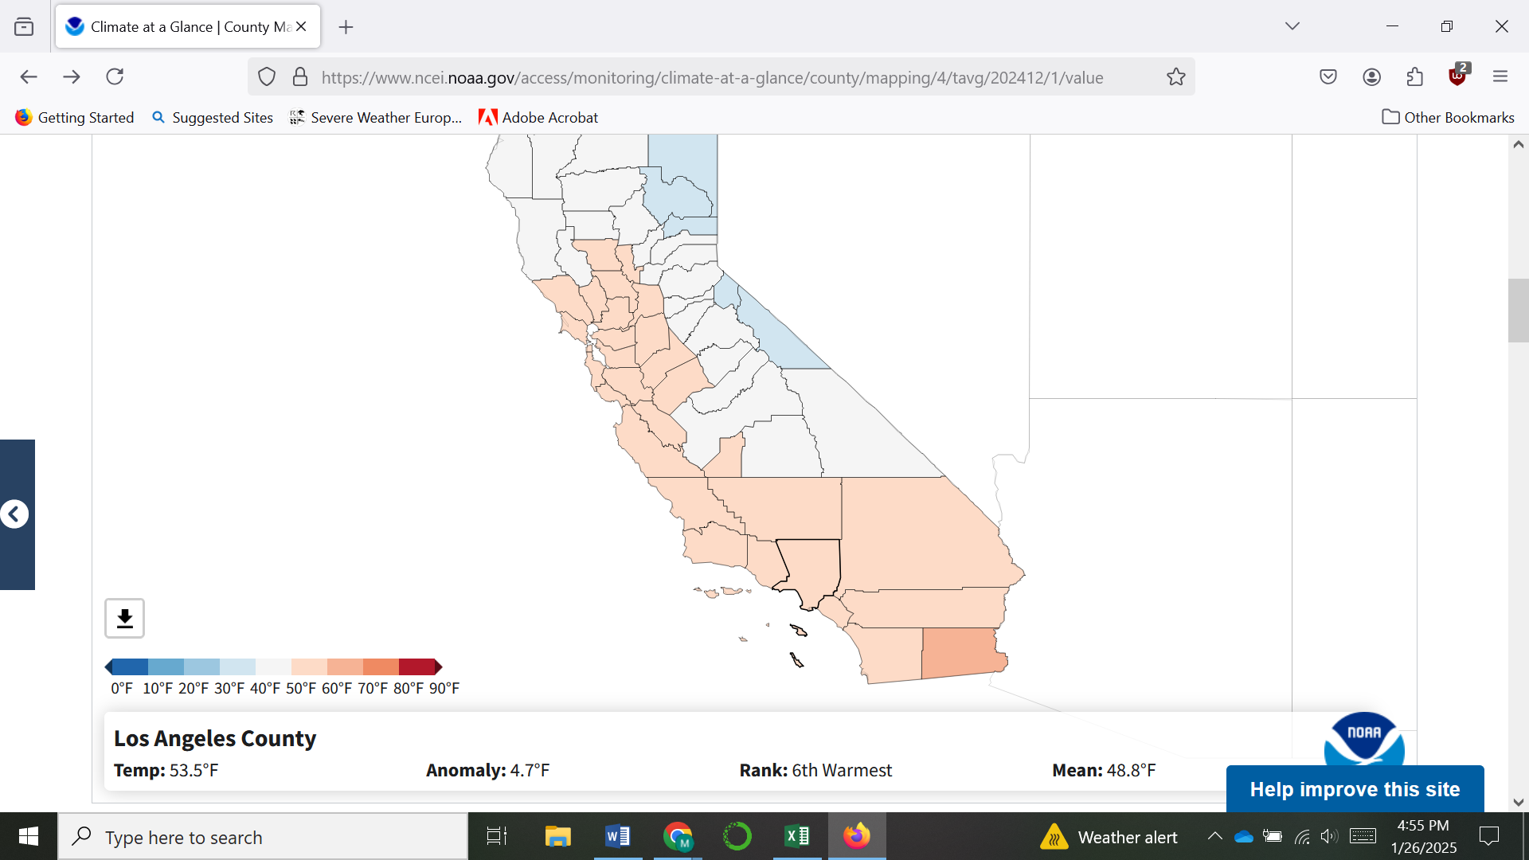

Next is your list of graphs to select and then download and post on two or three pages. View the Canvas-posted video that will walk you through the process. The rest of the questions you need to address follow.

First, as a context, have a look at these climate graphs of Los Angeles County:

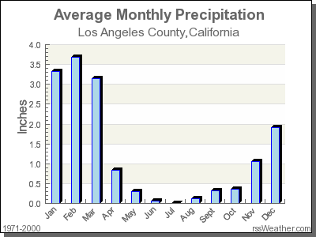

Is the seasonal pattern above fairly similar to what we experience in Western Oregon?

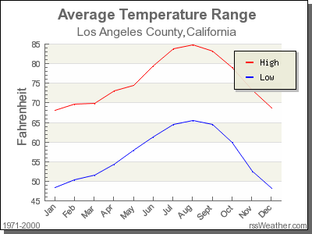

Now let’s have a look at the climate date in more detail over specific periods of time, following the basics as laid out in the video

November 2023 through March 2024 Precipitation:

Report the exact amount of precipitation for this period ending March 2024:

a) What is the mean precipitation of the November through March period from 1895 through 2024?

b) calculate by what percentage of the mean the period ending March 2024 was greater than the average of the whole time period. Do so by first coming up with the difference between the March 2024 value and the average of the whole time period, and then diving that number by the average of the whole time period. (yes, then to get the percentage rather than the decimal value, multiply the decimal value by 100). Your answer should read something like: *“the November 2023 through March 2024 precipitation was xx percent above the long term average going back to 1895.”*

*Right click the graph and save it on a google docs sheet.* You will eventually save several graphs and will paste them into two or three sheets.

------------------------------

June – October Temperature 2024

What was the average temperature for 2024?

How many June-October periods in the record going back to 1895 were warmer? (count them)

List the year or years that exceeded the June-October 2024 temperature:

What effect would these high temperatures have on the moisture in the soil and the vegetation?

*Right click the graph and save it on a google docs sheet.*

-------------------------------

October – December 2024 temperatures

What was the average temperature of this time period for 2024?

How many October-December periods in the record going back to 1895 were warmer?

Considering then the combination of having one of the very warmest ever June – October periods, and then following that with an extremely warm final two months of the year, how many years in the record show an even more extreme temperature record looking at those slightly overlapping periods?

Which year(s) was/were that?

What effect would these temperatures have on the moisture in the soil and the vegetation?

*Right click the graph and save it on a google docs sheet.*

-----------------------------------

October – December 2024 precipitation

Report the total October – December precipitation for 2024, mousing over the dot to get the exact amount:

Report all other years that had either an equally dry record for that time period, or drier, ranking from the driest to the value for 2024:

Report the slope of the line and whether it is positive or negative, reporting the beginning year (either 1895 or 1900) and the end year (2024).

Now, for a statistical lesson, pretend that we are doing this study in early 2023 rather than in later years. On the right margin of the “Trend” graph box, select the END button year 2022. Then report the slope of the precipitation line as seen above the axis on the right side: Is it negative or positive? Did it change much from your original.

Does the amount of change over a century plus seem like much?

Did it make any difference from what you had for the slope of the period ending in 2024? Discuss.

*Right click the graph and save it on a google docs sheet.*

August – December 2024 Palmer Z-INDEX

The Palmer Drought indexes use several different equation types. Palmer Drought Indexes account for previous month’s precipitation and temperature conditions, with cooler wetter years being green bars and positive values, drier years having negative signs and brown colored bars. We have used the August through December timeframe for this to capture the desiccating effects of the summer drought. The lower the brown bar dips in the graph, the drier it is (and the driest years have the greatest absolute value for the negative number – so that a -2.5 is drier than a -2.0, for example)

Mouse over the Palmer Z-Index for the five months ending December 2024, and report its value:

Mouse over the others that are of similar dryness, and list below by year which ones are drier, if any:

Have a look at the slope of the line of the Palmer Z index over time. Are conditions overall for this century plus time period trending drier or wetter?

Thinking about your answer to the question above, what appears to be more influential in causing the increasingly frequent and severe Palmer Z droughts, a) winter precipitation… or b) temperatures of the summer going through to the end of the year? (one way might be to think about this – is it more about rainfall or evapotranspiration?) Look at both graphs carefully. Discuss.

Write an essay of approximately 100 words summarizing what you did and what you found out about the cause(s) of the severe fires in January 2025. Explain to what degree the weather in the months leading up to the fires was significant, and how common or uncommon that weather was in the context of the last century plus. It should contain content from a significant number of the questions that you have answered.

About the Palmer Drought Indexes: <https://www.ncei.noaa.gov/access/monitoring/historical-palmers/overview#:~:text=Palmer%20Z%20Index%3A%20measures%20short,term%20drought%2Dinducing%20circulation%20patterns>.

<https://www.google.com/search?q=which+is+better+for+measuring+the+severity+of+flash+droughts%2C+the+PDSI+or+the+Palmer+Z+index%3F&rlz=1C1GCEA_enUS884US884&oq=which+is+better+for+measuring+the+severity+of+flash+droughts%2C+the+PDSI+or+the+Palmer+Z+index%3F&gs_lcrp=EgZjaHJvbWUyBggAEEUYOdIBCjMwMzUwajBqMTWoAgiwAgE&sourceid=chrome&ie=UTF-8>